Linux Fundamentals Lab Exercise

Objective
This lab demonstrates basic Linux commands for file management, text processing, shell scripting, and environment variables. Each task below lists the original question, the exact command(s) executed, and a terminal screenshot showing the actual output.

Task 1: Directory and File Operations
Question: Create a directory named linux_lab, navigate into it, create the files students.txt, script.sh and output.txt, then display the current working directory and list all files.
Command(s) used: mkdir linux_lab → cd linux_lab → touch students.txt script.sh output.txt → pwd → ls -l
Result / Screenshot:
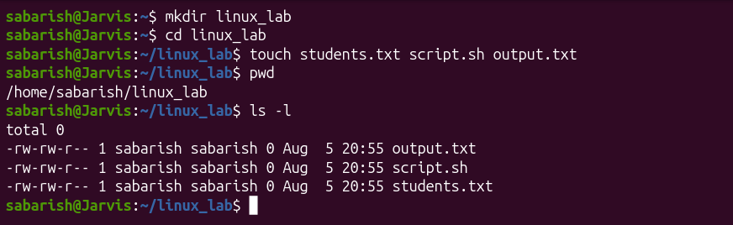
Result: The directory linux_lab was created and entered. All three required files (students.txt, script.sh, output.txt) were created successfully, as confirmed by the pwd and ls -l output above.

Task 2: Create and Edit a File
Question: Using a Linux text editor (nano or vim), add the given student records to students.txt, save it, and verify its contents.
Command(s) used: nano students.txt (edit & save) → cat students.txt
Result / Screenshot:
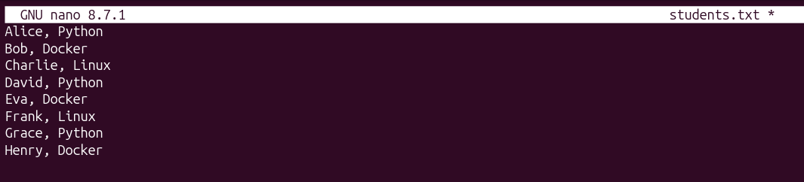
Result: students.txt was edited in nano and saved with all 8 student records. The cat command confirms the file contents match the required data exactly.

Task 3: Text Processing
Question: Display all records containing "Python", "Docker", and "Linux" respectively, using grep.
Command(s) used: grep "Python" students.txt | grep "Docker" students.txt | grep "Linux" students.txt
Result / Screenshot:
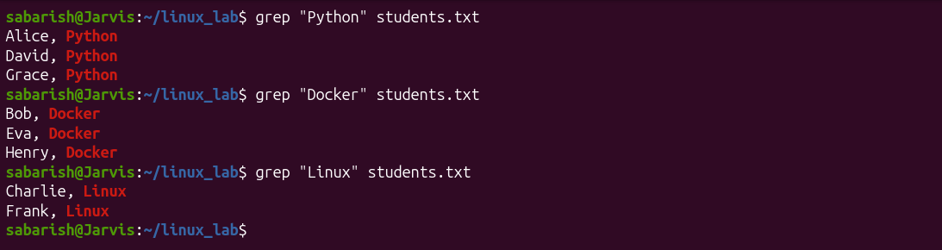
Result: grep successfully filtered and displayed 3 Python records, 3 Docker records, and 2 Linux records from students.txt.
Question: Count the number of records containing "Python", save that count into output.txt, and display the contents of output.txt.
Command(s) used: grep -c "Python" students.txt → grep -c "Python" students.txt > output.txt → cat output.txt
Result / Screenshot:
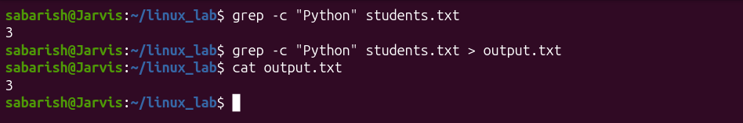
Result: The count of Python records is 3. This value was redirected into output.txt using the > operator, and cat output.txt confirms it was saved correctly.

Task 4: Shell Scripting
Question: Create a shell script script.sh that displays a welcome message, the current user, the current working directory, and the current date & time. Run the script from the terminal.
Command(s) used: nano script.sh (write script) → cat script.sh → chmod +x script.sh → ./script.sh
Result / Screenshot:
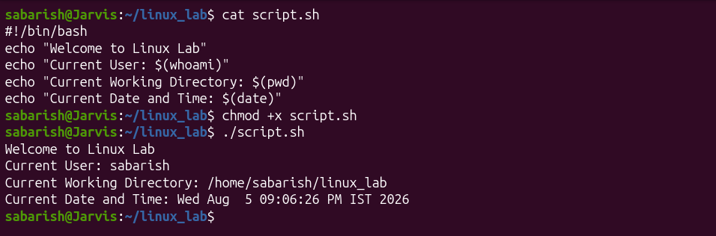
Result: script.sh was created with the required echo statements using $(whoami), $(pwd) and $(date), made executable with chmod +x, and executed successfully — printing the welcome message, current user, working directory, and system date/time.

Task 5: Environment Variables
Question: Create an environment variable COURSE_NAME with the value "Linux Fundamentals", display its value, verify it is exported, and then modify script.sh to also display COURSE_NAME along with the other system information.
Command(s) used: export COURSE_NAME="Linux Fundamentals" → echo $COURSE_NAME → env | grep COURSE_NAME → nano script.sh (edit) → cat script.sh → ./script.sh
Result / Screenshot:
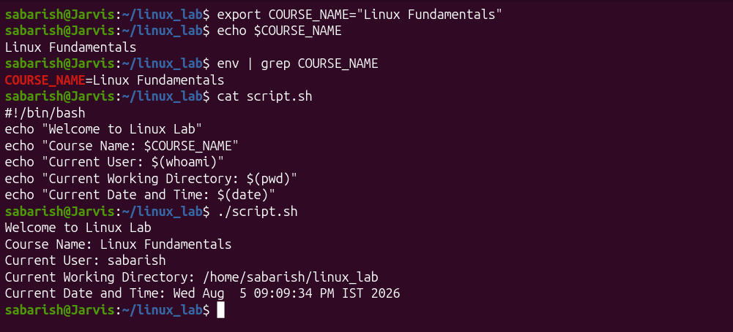
Result: The COURSE_NAME environment variable was created and exported successfully — confirmed via echo and env | grep COURSE_NAME. script.sh was updated to include an extra echo line for $COURSE_NAME, and running the updated script confirms it now prints the course name alongside the user, directory, and date/time.

Final File Contents (Submission)

students.txt
Alice,Python
Bob,Docker
Charlie,Linux
David,Python
Eva,Docker
Frank,Linux
Grace,Python
Henry,Docker

script.sh
#!/bin/bash
echo "Welcome to Linux Lab"
echo "Course Name: $COURSE_NAME"
echo "Current User: $(whoami)"
echo "Current Working Directory: $(pwd)"
echo "Current Date and Time: $(date)"

output.txt
3

Conclusion
All five tasks were completed successfully. This lab reinforced practical skills in directory/file operations (mkdir, touch, pwd, ls), file editing and verification (nano, cat), text processing and filtering (grep, grep -c, output redirection), shell scripting with command substitution ($(...)), and creating/exporting/using environment variables (export, echo, env) inside a shell script.

